(1)ED DIRGRAM
First, we build ERD (entity relationship diagram ) where we make a relationship to build a database diagram. It helps us to understand what we work on like our project Airplanes company, now we describe our whole project at our ERD.

ERD has 3 major relationship
1) one-to-one
2) one-to-many
3) many-to-many

We describe our ERD relationship table to table.

1) we make a passenger table whose column (passenger_id, passenger-name, passenger-surname, Gender, passenger-Email, contact-number)

2 ) Ticket table (ticket-id(PK), ticket-price,passanger-id(FK), departure, arrival,departure_date, arrival_date)

A relationship passenger table to ticket table is a one-to-many relationship

3)airplane Table (Airplane_id , Airplane_name , Model-number , manufacture,company_id, company_name)

4) Flight table(Flight_id(PK) ,Ticket_id(FK) ,departure , arrival,departure_date, arrival_date,Airplane_id(FK))

5) Crew table (Crew_id(PK),Flight_id(Fk),Crew_name, crew_surname, Gender, Contact_number,Salary, Crew_address, Designation)

(2)Normalization

Organizing the table in a way to reduce data redundancy, Normalization divides tables and there is a relation between them
1NF
- Reduce data redundancy
- Organized database
- Flexible database design

As we know first we go to 1NF and after then we can go 2NF and 3NF. we can't go directly 1NF to 3NF or we start from 2NF

1 NF follow this instruction
- No repeating values in a group
- No repeating group
2NF
Any non-key field should entirely depend on its primary key
- should be in 1NF
- No partial dependency
- Occurs when there is a composite key

3NF
Any non_key field dependent on other key field

- Should be in 1NF,2NF
- No transitive , dependency
- Occurs when , we can guess value of any column from non key column

we Normalization our project till 1NF ,because it does no partial dependency

(3)Data Definition Language ( DDL)

DDL Profmaing many institutions like create a table, drop table, alter table, rename table or column name, truncate table, we build a table by creating table privileges

NOTE

Create table: It gives privileges to make a table .

Alter table: Add a new column, Modify an existing column, help us to drop a column .

Drop table: We can drop a column from a table by using the ALTER TABLE statement with the Drop Column clause, We also drop the entire table .
i.e drop table table__name

Rename table: Changing the name table. i.e (Rename Airplane to aircraft).

Truncate table: Removes all rows from a table, releases the storage space used by the table
Constraints .
constraints enforce rules at the table level, we create a constraint at the same time we create the table or it already created.

Not Null: ensures that null values are not permitted for the column.

Unique: Unique requires that every value in a column or set of the column be unique, In simple words, it makes sure there is no same data in rows like a primary key does.

Primary key: only one primary key can be created for each table. it enforces the uniqueness of the column data.

Foreign key: foreign key establishes a relationship between a primary key or a uniques key in the same table or different table.

Check: The Check constraint defines a condition that each row must satisfy. The condition can use the same constructs as query conditions. references to the CURRVAL, NEXTVAL, LEVEL, and ROWNUM pseudo column. calls to SYSDATE,UID ,User and Usernv function.

(4)Data Manipulation Language (DML)

As DDL performs its task, we perform DML to insert, update, delete, merge

NOTE

Insert: add new rows to a table by using the insert statement.
Update: modify existing our table row by using an update statement .
Delete: We can remove existing rows from the table by using a delete statement.
Merge: provides the ability to conditionally update or insert data into a database table .

(5)SQL QUERIES

Queries which we retrieved.

first, we are going to explore some base SQL queries to retribution data.

Select: Select identifies what columns we want .
From: From Identifies which table.
Where: Restrict the rows returned by using the WHERE clause.
Like: Use the LIKE condition to perform wildcard searches of valid search string values.

Queries

Desc or Describe table_name: to show created table structure
Star (*): It show us tables data
i.e Select* from ticket;

NOW WE ARE GOING TO MAKE SOME QUERIES

1)Select airplane_id , company_id
From airplane;

2) Select crew_id , Flight_id , Designation
from crew
where flight_id=507999

3) select Flight_id , departure, Arrival
from Flight
Where departure like 'Dubai%' ;

4) Select Passanger_id
from passanger
where Gender like '% M' ;

5)Select passanger_id , Arrival_date
from Ticket
(1) preforming (add/delete/update) on table Crew
Query
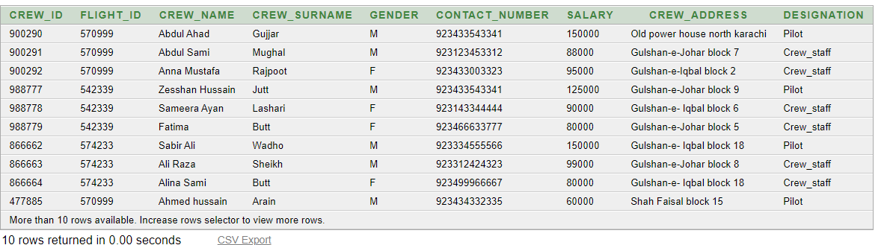
Select * from crew ;
Explanation: We just run our data
Query
alter table crew
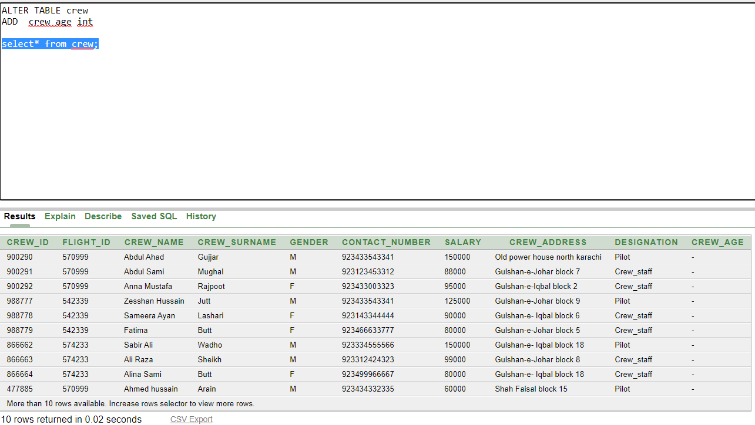
add crew_age int;

Explanation: We add a new column 'crew_age' after Designation .

Query
alter table crew
drop column crew_address ;
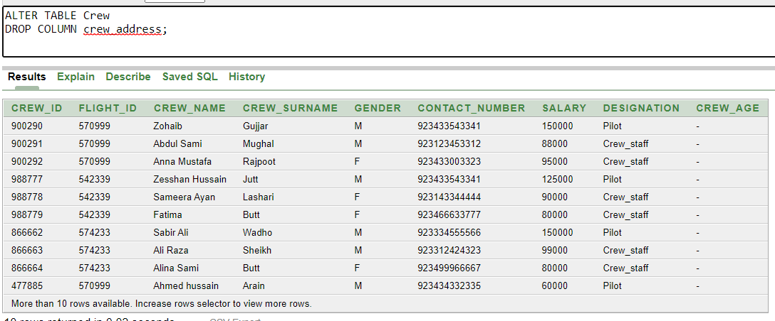
Explanation: We drop one column from crew table which is 'crew_address' .

Query
update crew
set crew_name ='Zohaib'
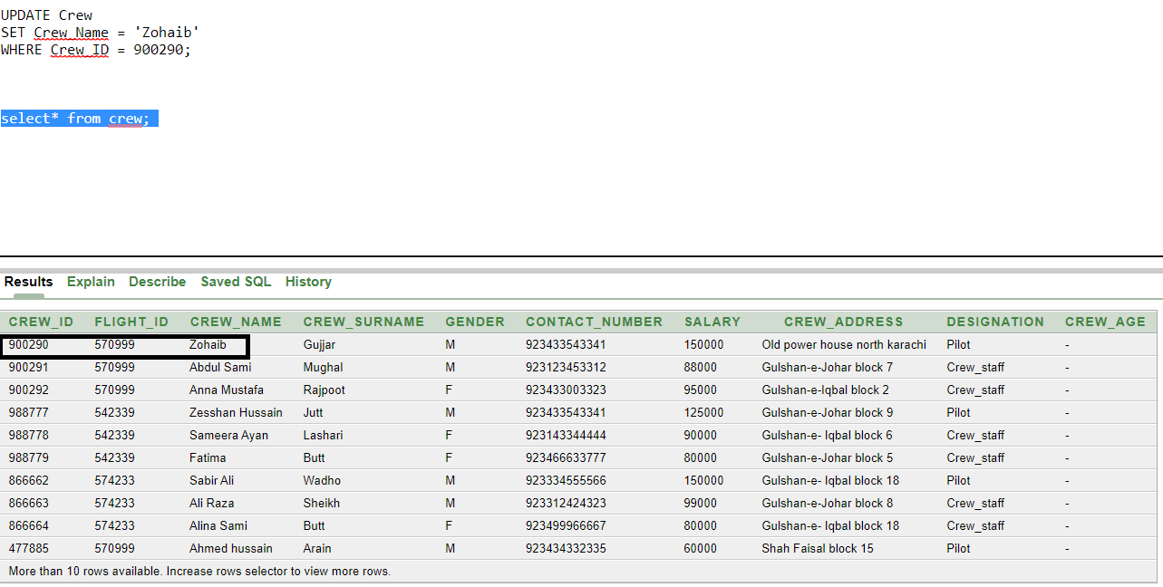
Where Crew_id=900290 ;
Explanation: We update the column data with 'Zohaib' after 'Abdul Ahad'

(2) preforming (add/delete/update) on table Flight
Query
Select * from flight ;
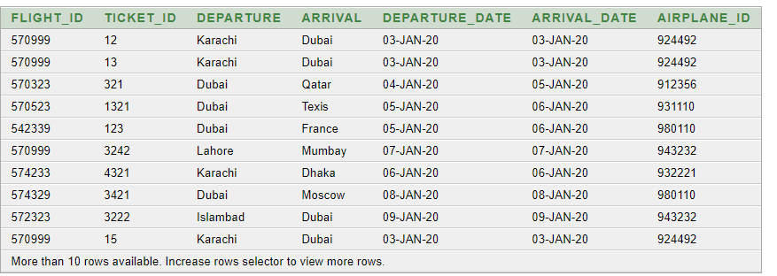
Explanation: We just run our data

Query
Alter table Flight
Add Flight_Average int ;

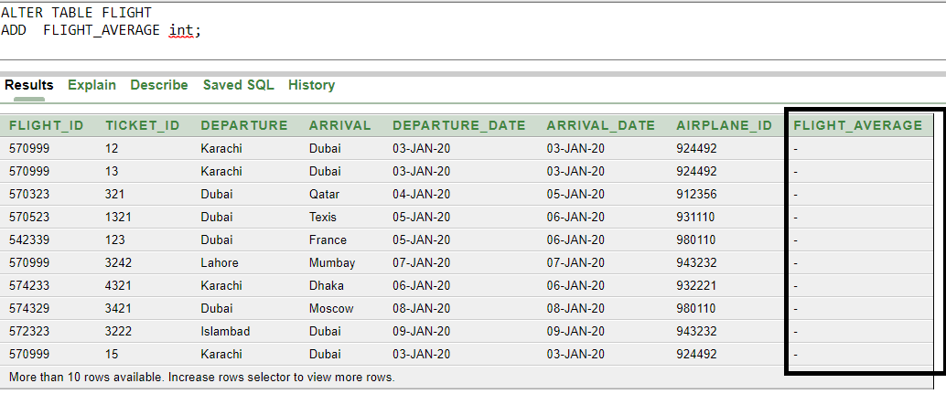
Explanation: We add new column flight Average after airplane id.

Query

alter table flight
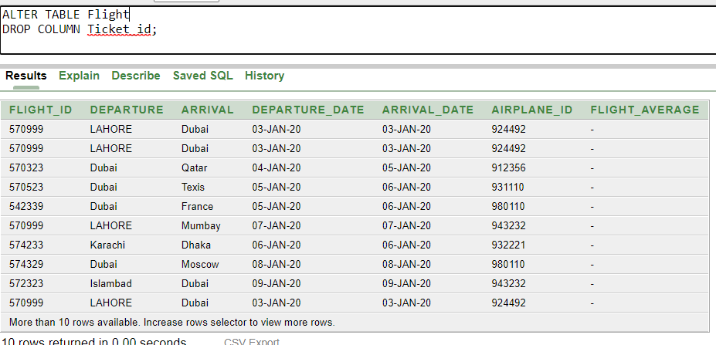
drop column ticket_id ;

Explanation: We drop our column ticket id from flight table .

Query
Update flight
set departure = 'Lahore'
Where Flight_id = 570999 ;

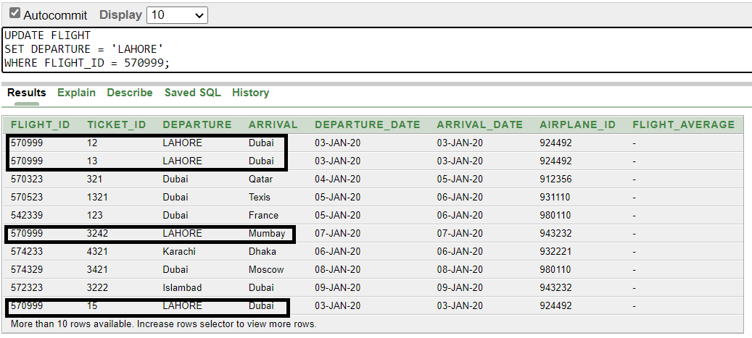
Explanation: We update the column data with 'Karchi' to 'Lahore' where flight id is 570999.
It mean we changed data where flight id is 570999 .

\

(3) preforming (add/delete/update) on table Airplane

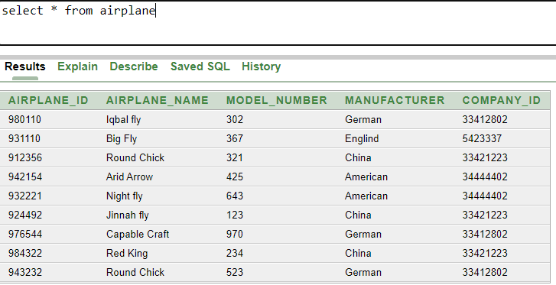
Select * from airplane.

Query
Alter table airplane
Add Engine_fan Int ;
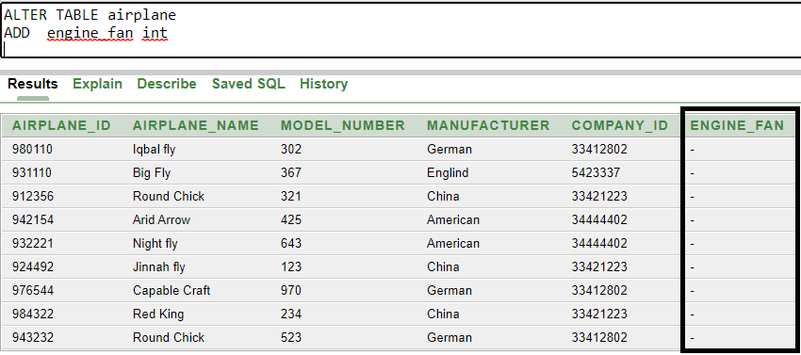
Explanation: We add new column flight Average after airplane id.
Query
Query
Alter table Airplane
Drop column Model_number ;
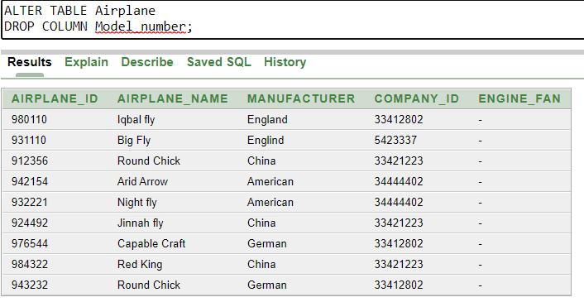
Query
Update airplane
Set manufacturer=’England’
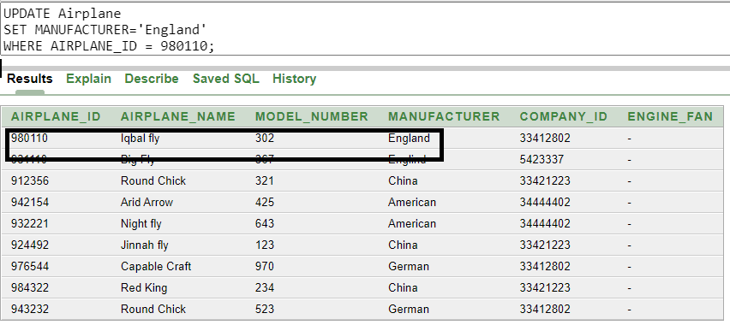
Where airplane_id=980110;

Explanation: We update the column data with ‘German’ to ‘England’ where Airplane id is 980110.
(4)Browse
- Booking details

Ticket_id | Ticket_price | Departure | Arrival | Departure_date | Arrival_date
12 | 50000 | Karachi | Dubai | 03/01/20 | 03/01/20
13 | 50000 | Karachi | Dubai | 03/01/20 | 03/01/20
14 | 50000 | Karachi | Dubai | 03/01/20 | 03/01/20
15 | 50000 | Karachi | Dubai | 03/01/20 | 03/01/20
321 | 50000 | Dubai | Qatar | 04/01/20 | 04/01/20
1321 | 200000 | Dubai | Texis | 05/01/20 | 06/01/20
123 | 100000 | Dubai | France | 05/01/20 | 06/01/20
3242 | 35000 | Lahore | Mumbay | 07/01/20 | 07/01/20
4321 | 30000 | Karachi | Dhaka | 06/01/20 | 06/01/20
3421 | 90000 | Dubai | Moscow | 08/01/20 | 08/01/20
3222 | 30000 | Islamabad | Dubai | 09/01/20 | 09/01/20
2323 | 39000 | Lahore | New Delhi | 06/01/20 | 06/01/20

- Machine Details and list of Pilots

Airplane_id | Airplane_name | Flight_id | Crew_id | Crew_name | Crew_surname
924492 | Jinnah fly | 570999 | 900290 | Abdul Ahad | Gujjar
912356 | Round Chick | 570323 | 899772 | Fayaz Ahmed | Qureshi
931110 | Big Fly | 570523 | 677738 | Faisal Ali | Shah
980110 | Iqbal fly | 542339 | 988777 | Zesshan Hussain | Jutt
932221 | Night fly | 574233 | 866662 | Sabir Ali | Wadho
980110 | Iqbal fly | 574329 | 239995 | Umar Taj | Zardari
943232 | Round Chick | 572323 | 899772 | Fayaz Ahmed | Qureshi
932221 | Night fly | 532299 | 477885 | Ahmed hussain | Arain

- Passangers booking

Passanger_id | Departure | Arrival | Departure_date | Arrival_date
79210 | Karachi | Dubai | 03/01/20 | 03/01/20
79211 | Karachi | Dubai | 03/01/20 | 03/01/20
79212 | Karachi | Dubai | 03/01/20 | 03/01/20
79213 | Karachi | Dubai | 03/01/20 | 03/01/20
77443 | Dubai | Qatar | 04/01/20 | 04/01/20
24444 | Dubai | Texis | 05/01/20 | 06/01/20
25333 | Dubai | France | 05/01/20 | 06/01/20
33211 | Lahore | Mumbay | 07/01/20 | 07/01/20
42112 | Karachi | Dhaka | 06/01/20 | 06/01/20
98989 | Dubai | Moscow | 08/01/20 | 08/01/20
77666 | Islamabad | Dubai | 09/01/20 | 09/01/20
66644 | Lahore | New Delhi | 06/01/20 | 06/01/20

(5)Making a new booking
- For one or more passanger
Ticket_id | Ticket_price | Departure | Arrival | Departure_date | Arrival_date
176 | 88000 | Karachi | Dubai | 16/02/20 | 16/02/20
187 | 78000 | Lahori | Dubai | 17/02/20 | 17/02/20
16 | 56000 | Karachi | Islamabad | 16/02/20 | 16/02/20

(6)Generate Reports
- Pilots Schedule by Month

Airplane_id | Flight_id | Crew_id | Crew_name | Departure | Arrival | Departure_date | Arrival_date
924492 | 570999 | 900290 | Abdul Ahad | Karachi | Dubai | 01/02/20 | 11/02/20
912356 | 570323 | 899772 | Fayaz Ahmed | Karachi | Lahore | 01/02/20 | 11/02/20
931110 | 570523 | 677738 | Faisal Ali | Karachi | New Dehli | 01/02/20 | 11/02/20
980110 | 542339 | 988777 | Zesshan Hussain | Karachi | Islamabad | 01/02/20 | 11/02/20
932221 | 574233 | 866662 | Sabir Ali | Karachi | Quetta | 01/02/20 | 11/02/20
980110 | 574329 | 239995 | Umar Taj | Karachi | Swat | 01/02/20 | 11/02/20
943232 | 572323 | 899772 | Fayaz Ahmed | Karachi | Mumbay | 01/02/20 | 11/02/20
932221 | 532299 | 477885 | Ahmed hussain | Karachi | Hyderabad  (India) | 01/02/20 | 11/02/20
924492 | 570999 | 900290 | Abdul Ahad | Dubai | Islamabad | 11/02/20 | 19/02/20
912356 | 570323 | 899772 | Fayaz Ahmed | Lahore | Dubai | 11/02/20 | 19/02/20
931110 | 570523 | 677738 | Faisal Ali | New Dehli | Islamabad | 11/02/20 | 19/02/20
980110 | 542339 | 988777 | Zesshan Hussain | Islamabad | Sukker | 11/02/20 | 19/02/20
932221 | 574233 | 866662 | Sabir Ali | Quetta | Swat | 11/02/20 | 19/02/20
980110 | 574329 | 239995 | Umar Taj | Swat | New Dehli | 11/02/20 | 19/02/20
943232 | 572323 | 899772 | Fayaz Ahmed | Mumbay | Lahore | 11/02/20 | 19/02/20
932221 | 532299 | 477885 | Ahmed hussain | Hyderabad  (India) | Lahore | 11/02/20 | 19/02/20
924492 | 570999 | 900290 | Abdul Ahad | Islamabad | Karachi | 19/02/20 | 28/02/20
912356 | 570323 | 899772 | Fayaz Ahmed | Dubai | Karachi | 19/02/20 | 28/02/20
931110 | 570523 | 677738 | Faisal Ali | Islamabad | Karachi | 19/02/20 | 28/02/20
980110 | 542339 | 988777 | Zesshan Hussain | Sukker | Karachi | 19/02/20 | 28/02/20
932221 | 574233 | 866662 | Sabir Ali | Swat | Karachi | 19/02/20 | 28/02/20
980110 | 574329 | 239995 | Umar Taj | New Dehli | Karachi | 19/02/20 | 28/02/20
943232 | 572323 | 899772 | Fayaz Ahmed | Lahore | Karachi | 19/02/20 | 28/02/20
932221 | 532299 | 477885 | Ahmed hussain | Lahore | Karachi | 19/02/20 | 28/02/20

